

**Asset Practice Answers: Mathematics**

1. Shown below are two bundles with 16 sticks in each.

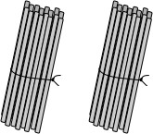

If you untie the sticks and put them in bundles of 8 each, how many bundles will you get?

A. 2

**B. 4**

C. 8

D. 16

2. A number is multiplied by 1. The answer will always be

A. 0.

B. 1.

**C. the number itself.**

D. 1 more than the number.

3. Javed is playing a computer game where he has to make his frog move from the ''Start'' flag to the

''Finish'' flag by jumping on the tiles in between. He gains 100 points for jumping on a white tile and

loses 50 points for jumping on a grey tile. On reaching the ''Finish'' flag, he gains 100 extra points.

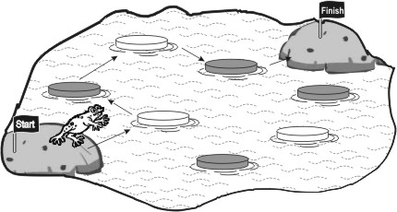

If the frog takes the path as shown in the picture, how many points will he score?

A. 0

B. 100

**C. 200**

D. 300

4. Bob is playing a board and dice game called 'Car Race' with his friend. A part of the board is shown below:

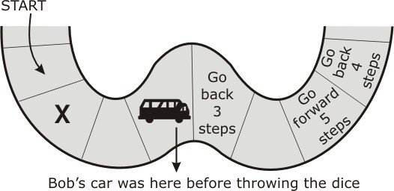

Bob's car is shown on the board. After throwing the dice, his car had to move to the place marked 'X'. What number did he throw on the dice?

**A. 1**

B. 2

C. 3

D. 4

5. A classroom has a wall chart listing numbers from 1 to 100. A PART of it is shown below.

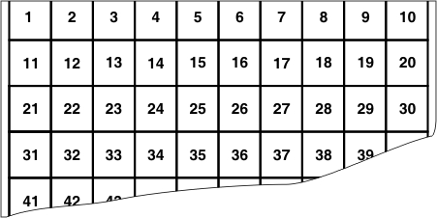

On this chart, the numbers 11, 21, 51 and 91 can be connected by a straight line. Which of the following set of numbers can also be connected by a single straight line on this chart?

A. 2, 4, 24, 42

B. 5, 10, 15, 20

C. 23, 24, 33, 34

**D. 25, 34, 43, 52**

6. For a festival in Kanthi's house, a chain of bulbs is hung in her puja room. The bulbs in the chain are arranged in a pattern as shown below.

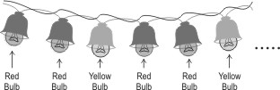

How many red bulbs will be there in the chain if there are 12 bulbs altogether?

A. 2

B. 4

**C. 8**

D. 12

7. 25 children are standing in a line to play a game. They are given numbers 1 to 25 to identify themselves. Then, every 4 thchild in the line is asked to come a little forward.

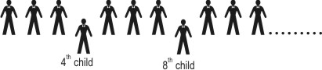

One of the children who came forward could be the child.

A. 2 nd child

B. 10 th child

**C. 24 th child**

D. 25 th child

8. These shapes are arranged in a pattern.



Which number series follows the same pattern as the shapes?

**A. 12122122212222**

B. 12121212121212

C. 12112211122211

D. 11221122112211

9. Students from classes 4-A, 4-B and 4-C will take part in a group dance. So we need to select an equal number of girls from each class, to have 21 girls in the dance. In the same way we need to select an equal number of boys from each class, to have 15 boys in the dance. How many students do we need to select from each class?

A. 5

B. 7

**C. 12**

D. 36

10. The two number sequences below follow the same pattern. 2, 4, 8, 16......and so on 3, 6, 12, 24....and so on Which sequence below follows the same pattern as the two number sequences above?

A. 2, 4, 6, 8....and so on

B. 3, 6, 9, 12....and so on

C. 5, 10, 15, 20.....and so on

**D. 10, 20, 40, 80.....and so on**

11. Some juice is poured into 3 jars as shown here.





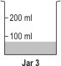

Which of the following is true?

A. Jar 3 has the most amount of juice.

**B. Jar 2 has the most amount of juice.**

C. Jar 1 has the most amount of juice.

D. Jars 2 and 3 have equal amount of juice.

12. The same ball is used to check the weight of an apple and a mango.

Here is how the balance looks for the apple and the mango.

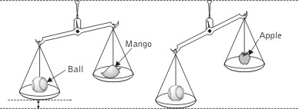

What can be said about the weight of the mango from the figure? (Hint: Look how far down, the pan with the ball has gone.)

A. It is same as that of the apple.

B. It is less than that of the apple.

C. It is greater than that of the ball.

**D. It is greater than that of the apple.**



**Math’s**

1. B: If you untie one bundle of 16 sticks and put them in bundles of 8 how many bundles would you get? 2, Right! Now we have 2 such bundles of 16 and we get 2 bundles of 8 from each. So we get 4 bundles of 8 in all.

2. C: A number multiplied by 1 will give the number itself. For example 7 x 1 = 7. That is one times any number is the number itself. You may also verify 9 x 1 = 9, 100 x 1 = 100 etc, and with any other number.

3. C: The frog jumps on two white tiles and two grey tiles. So Javed will gain 2 x 100 points for stepping on 2 white tiles. He will lose 2 x 50 points for stepping on 2 grey tiles. As he reaches "Finish" flag he will also gain 100 more points. Thus Javed's score = 200 - 100 + 100 points = 200 points.

4. A: You move as many positions on the board as the number on the dice towards the finish point in the game. Bob's car had to be moved two places behind from its current position to the place marked X. If Bob's car comes to the place with the instruction "Go back 3 steps", it would have to be moved to the place marked X. So Bob must have got 1 on the dice on his throw.

5. D: The numbers 2 and 4 can be connected by a straight line. But 24 and 42 will not be on the line. So A cannot be the answer. Similarly 5 and 10 can be connected by a horizontal line. But 15 and 20 will not be on that line. So B cannot be the answer. Same is the case with numbers 23, 24, 33 and 34. Hence C cannot be the answer. Draw a slant line connecting 25 and 34. If the line is extended will it not contain numbers 43 and 52? It does and hence D is the answer. The numbers 6, 15, 24 and 33 can be connected by a slant line. Can you find more such numbers which can be connected by a slant line? Do you find a pattern in these numbers?

6. C: After every 2 red bulbs there is a yellow bulb in the pattern. There will be 12 ÷ 3 = 4 yellow bulbs in the chain with 12 bulbs altogether. So there will be 4 x 2 = 8 red bulbs in the chain. It can be seen that the unit shown below is repeated to form the pattern.

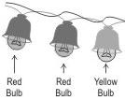

7. C: All 25 children are made to stand in a line. They are given numbers. The first child in the line is given the number 1, the second child, the number 2 and so on. Every 4th child in the line is asked to come forward. The children numbered 4 and 8 come forward. Among the children in the line with numbers 1, 2 ... 25, which ones will come forward? The ones with numbers 4, 8, 12, 16, 20 and 24, right? The second last child cannot be said to be the 2nd child and hence A is not correct.

8. A: If we replace a square in the pattern by 1 and a circle by 2, do we not get the pattern as in A? So the pattern in A is similar to the given pattern in shapes. Try extending any of the patterns to next 5 terms.

9. C: 21 girls are to be selected from three classes 4-A, 4-B and 4-C. An equal number of girls from each of the 3 classes are to be selected. So the number of girls to be selected from each of the classes is 21 ÷ 3 girls. Similarly 15 boys are to be selected with an equal number of boys from each of the three classes. So the number of boys to be selected from each of the three classes is 15 ÷ 3. In all, 7 girls and 5 boys are to be selected from each of the three classes. Hence C is the answer. 36 students are to be selected in all from the 3 classes and not from each of the classes. So D is not the answer.

10. D: Observe the pattern 2, 4, 8, 16... A number is obtained from the previous number by multiplying it with 2. Similarly in the pattern 3, 6, 12, 24...each number is obtained from the previous number by multiplying it with 2. In which of the given 4 patterns, numbers are obtained using the same rule? Is it not the pattern 10, 20, 40, 80 etc? In the pattern 2, 4, 6, 8... each number is obtained from the previous number by adding 2 to it. So A is not the answer.

11. B: The level of juice in Jar 1 is a little more than the 50 ml mark. So Jar 1 has a little more than 50 ml juice. Jar 2 has

100 ml juice. Jar 3 has a little less than 100 ml juice. So Jar 2 has the most amount of juice. Jar 1 has a narrower base

than jar 2. So even though juice is filled up to a greater height than that in the other jars, it contains the least amount of juice. Try pouring a cup of water from a cup into a jar and check the water levels in both the cases. Both contain the same amount of water but their water levels are different.

12. D: If you place a lighter object and a heavier object on two pans of a simple balance, what do you observe? Do you see that the pan with the heavier object tilts downwards? The lighter the object on the other pan, the more tilted will be the pan with the heavier object. The pan with the ball is more tilted downwards when there is an apple on the other pan. So, the mango is heavier compared to the apple.